MTH2010 Readings and Assignments: Week 1

Week 1 Readings
As early in the week as possible, please read:
- Week 1 online lectures.
- The following sections from Chapter 1 (Line and Angle Relationships) of the text Elementary Geometry:
  - Section 1.1-pg. 2-9 (Also read Examples 1-9),
  - Section 1.2- pg. 9 -19 (Also read Examples 1-8),
  - Section 1.3- pg. 20-29 (Also read Examples 1-4), and
  - Section 1.4-pg. 30-36 (Also read Examples 1-4).
Week 1 Assignments Overview
Assignment Summary Week 1: | Due Date
Assignment 1: Autobiography | Friday, February 20, 2009
Assignment 2: Discussion Questions | Friday, February 20, 2009
Assignment 3: Exam | Sunday, February 22, 2009
Assignment 4: Discussion on Exam | Monday, February 23, 2009
Using the navigation on the left, please proceed to the next page.

Week 01

Learning Outcomes
• Identify the four components of a mathematical system.
• Identify three types of reasoning used to develop geometric relationships.
• Describe basic terms in geometry.
• Measure line segments and angles.
• Describe different types of angles.

Lines and Line Segments
Welcome to Week 1 of College Math II.
Centuries ago, people needed a way to measure land and as a result we have geometry. The word geometry comes from the words geo, meaning earth, and metron meaning measure. Geometry is important today not only for measuring land, but it is also important in architecture, art and design, construction, navigation, physics, chemistry, and astronomy. Let's look at some basic geometric terms first. Geometry starts with the idea of a point.
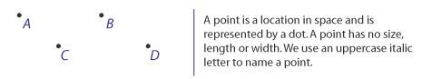
A line is a straight row of points that goes on forever in both directions. Several points on a line form a straight path. A line using arrowheads shows that it never ends. A line is one-dimensional, as opposed to a point, which has no dimension; in essence, we can talk about trying to measure the distance between any two points on a line.
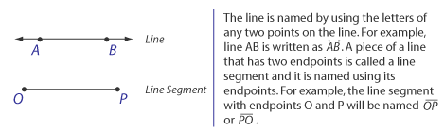

Basic Terms: Lines and Planes
A plane is a flat surface, like the floor below you, or like a wall. A plane is two-dimensional. It has infinite length and infinite width, but no thickness. We use an uppercase letter to name a plane.
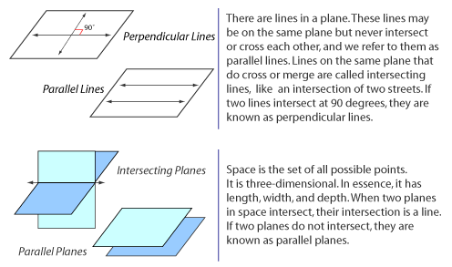

Lines and Angles
A ray is part of a line that has only one endpoint and goes on forever in one direction. When we name a ray, we always mention the endpoint first.
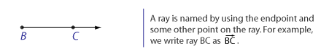
An angle is made up of two rays that start at a common endpoint, or we can say it is a union of two rays that share a common endpoint. We name this common endpoint as the vertex. When naming an angle, the vertex is written alone, or it is written in the middle of two other points. For example, we may write or to name an angle with vertex B. We measure angles in degrees, and the symbol that we use for degrees is a small, raised circle °. To measure the number of degrees in an angle, we use a protractor. The measures of angles are usually between 0° and 180°, including 180°. Acute angles measure between 0° and 90°. Obtuse angles measure between 90° and 180°. If the angle measures exactly 90°, we call it a right angle, while an angle that measures exactly 180° is called a straight angle.
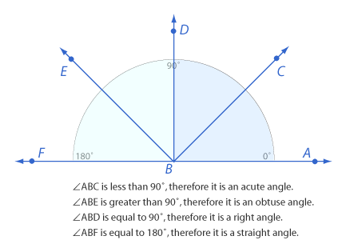

Angles and Their Relationships
Two angles are called complementary angles if their sum is 90°. If two angles are complementary, each angle is said to be the complement of the other.
Two angles are called supplementary angles if their sum is 180°. If two angles are supplementary, each angle is said to be the supplement of the other.
Two angles are called congruent angles if they measure the same number of degrees. If two angles are congruent, this is written as and we read it as "angle A is congruent to angle B."
Two angles that share a common side are called adjacent angles. Angles that do not share a common side are called nonadjacent angles.
Two nonadjacent angles formed by intersecting lines are called vertical angles. If two angles are vertical, they are congruent (that is, they have the same measure in terms of degrees).
Besides knowing the basic terms in geometry, you also need to be aware of what a statement is and what the different types of reasoning are. A statement can be true or false. A statement can take on three forms known as conjunction, disjunction, and negation. Let's say you have two short statements A and B. The statement of the form A and B is a conjunction, and the statement of the form A or B is a disjunction. A conjunction is true only when A and B are both true. A disjunction is false only when A and B are both false. A negation makes an opposite claim of the original statement. For example, if we say all ten of the kids are girls, then to negate that we can say some of the ten kids are boys where we are saying that at least one kid is a boy.
The statement of the form "If A, then B" is known as a conditional statement, or implication. In this form, A is the hypothesis, and B is the conclusion. If the hypothesis is true, it implies that the conclusion made in B is also true. To make our conclusions, we need to be able to reason and there are three different types of reasoning that we can use. One has a choice of doing reasoning by induction, deduction, or by intuition.

Assignment 01 – Biography
Assignment 2: Discussion Questions
By Friday, February 20, post your responses to the two discussion questions assigned to you by your facilitator in the Discussion Area. Your response should reflect an understanding of the material covered as it applies to your life, work, and educational experiences. Start reviewing and responding to your classmates as early in the week as possible; post comments on at least two of your classmates' submissions to the Discussion Thread. Please refer to the policy for participation found in the Educational Commitment Statement.

Grading Criteria | Maximum Points
Correct explanation of concepts. | 4
Well-formed conclusions. | 4
Participation in discussion with class, feedback and comments. | 4
Correct spelling and grammar. | 4
Total: | 16
For assistance with any problems you may have when completing this assignment—OR—to offer your assistance to classmates, please use the Problems and Solutions Discussion area located through the left side navigation link.
Read First: Guidelines
Answer 2 out of the 3 questions from the pull-down menu. You get to pick which two to answer. This should be completed by Day 2, Friday.
Your responses should be thorough and comprehensive. Include explanations and examples when necessary. Most importantly, show all your work and explain your steps. A minimum of 3 paragraphs is required. Spell check your work before posting.
Also, respond to the postings of at least 2 other students. These responses should begin on Day 3, Saturday and continue throughout the week. They are due by the very latest on Day 7, Wednesday, but every effort should be made to post them earlier.
DQ 1 - State briefly in your own words your understanding of the different types of thinking or reasoning: induction, deduction, and intuition. Give examples of each type of reasoning.
DQ3 - What do we gain by studying geometry?
DQ 5 - What are the characteristics of a good definition in geometry?

Assignment 4: Discussion on Quiz
By Monday, February 23, 2009, look at the questions 11 to 15 in the Week 1 exam. Select any three questions and present to the class how you solved the questions. Post your responses to the Discussion Area.
Review and critique the work of at least two other students by the end of the week and post your comments to this Discussion Area.
Grading Criteria | Maximum Points
The solutions present show understanding of concept. | 4
Participation and feedback. | 4
Total: | 8
For assistance with any problems you may have when completing this assignment—OR—to offer your assistance to classmates, please use the Problems and Solutions Discussion area located through the left side navigation link.

Quiz Questions 11-15
11. Which type of reasoning is used in the following situation? If a number is even, then it can be divided exactly by two. Six is even. Therefore, six can be divided exactly by two.
Intuition
Deduction
Induction
None of these
12. Which statement is false?
If two lines are perpendicular to the same line, they are perpendicular to each other.
If two lines are parallel to the same line, they are parallel to each other.
If two lines intersect, their intersection is a point.
If two planes intersect, their intersection is a line.
13. 1 and 2 are complementary. If m1 = 73, how much is 2?
17
46
36
56
14. Given that A-P-B are on segment AB, which statement is not necessarily true?
A, P, and B are collinear.
P is between points A and B.
P is the midpoint of segment AB.
AP + PB = AB.
15. Perpendicular lines are two lines that:
Do not intersect each other
Meet to form congruent adjacent angles
Meet to form vertical angles
Form an angle of 120 degrees

